

### College of Engineering

Department of Mechanical Engineering

Project Management Plan (PMP)

Engineering Design-Senior Design, ME-490A

Project 18, Team M9, Automated Microgreen Growing Machine

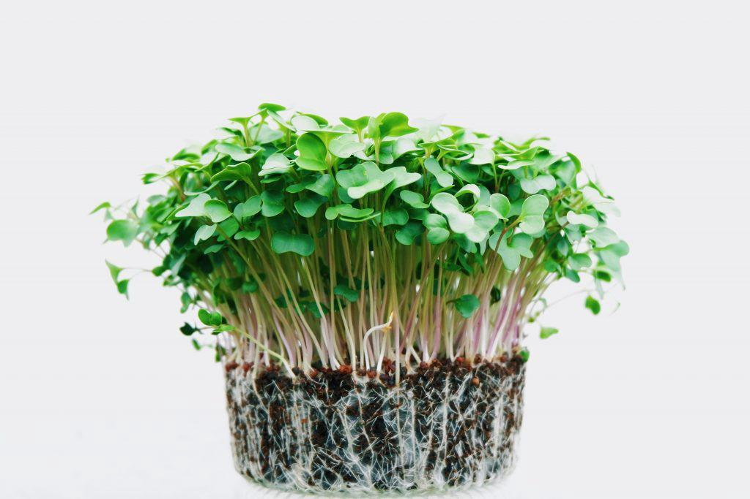

Mean Green Growing Machine

John Berger, Max Merritt, Thuyavan Sathiamurthi, Conor Vasiliadis

18 September 2020

# 

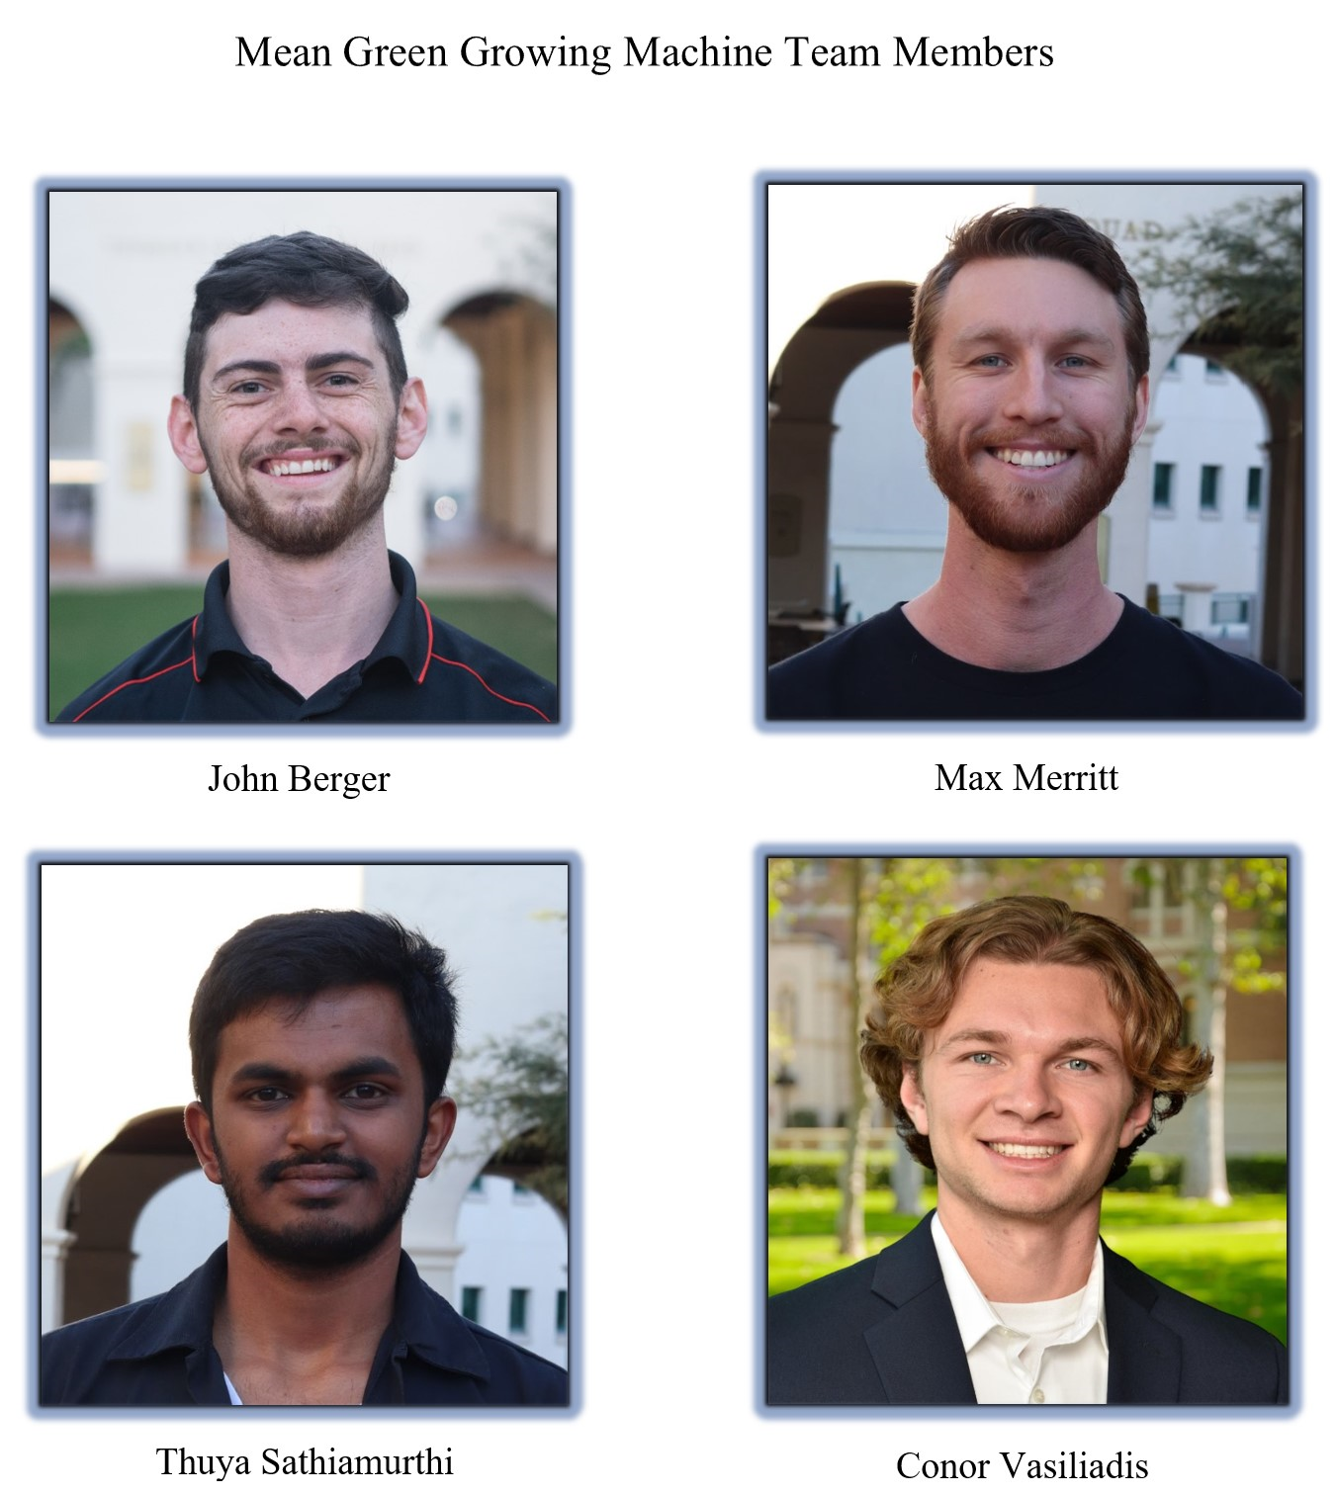

Table of contents **2**

**Table of Figures** **2**

**1.0 Scope** **4**

Work Breakdown Structure (WBS) 4

Statement of Work (SOW) 6

**2.0 Schedule** **7**

Integrated Master Plan (IMP) 7

Integrated Master Schedule (IMS) 7

**3.0 Budget** **10**

Budget For Labor and Materials 10

Management Reserve 10

**4.0 Team Organization** **11**

Team Organization Chart 11

Team Charter 12

People Resources 13

**5.0 Procurement Plan** **14**

Supplier List 14

**6.0 Risks and Opportunities** **15**

Risk Chart 15

Risk Mitigation 16

Risk Cube 17

# 

# Table of Figures

1

**1.0 Scope**

Figure #1 WBS Tree View 4

Figure #2 WBS Table View 5

**2.0 Schedule** **7**

Figure #3 IMP Timeline 7

Figure #4 IMS Gantt Chart ME-490A 8

Figure #5 IMS Gantt Chart ME-490B 9

**3.0 Budget** **10**

Table #1 Estimated Labor and Materials Budget 10

**4.0 Team Organization** **1**1

Figure #6 Team Organization Chart 11

Table #2 Team Charter 12

Table #3 People Resources 13

**5.0 Procurement Plan** **1**4

Table #4 Projected Materials Cost 14

Table #5 Distributor List 14

**6.0 Risks and Opportunities** **1**5

Table #6 Risk Levels and Likelihoods 15

Table #7 Risk Consequence Criteria 15

Table #8 Risk Reporting List 16

Figure #7 Risk Reporting Cube 17

# 

# 1.0 Scope

## Work Breakdown Structure (WBS)

# 

Figure # 1 WBS Tree View

The work breakdown structure provides a high level overview of all of the work that needs to be completed to achieve project success. A seven digit document labeling strategy is employed throughout Team M9’s resources. This creates traceability from the WBS through the IMS and down into the part file level.

A live version of the team WBS can be viewed here:<https://bit.ly/2ZM1ELx>

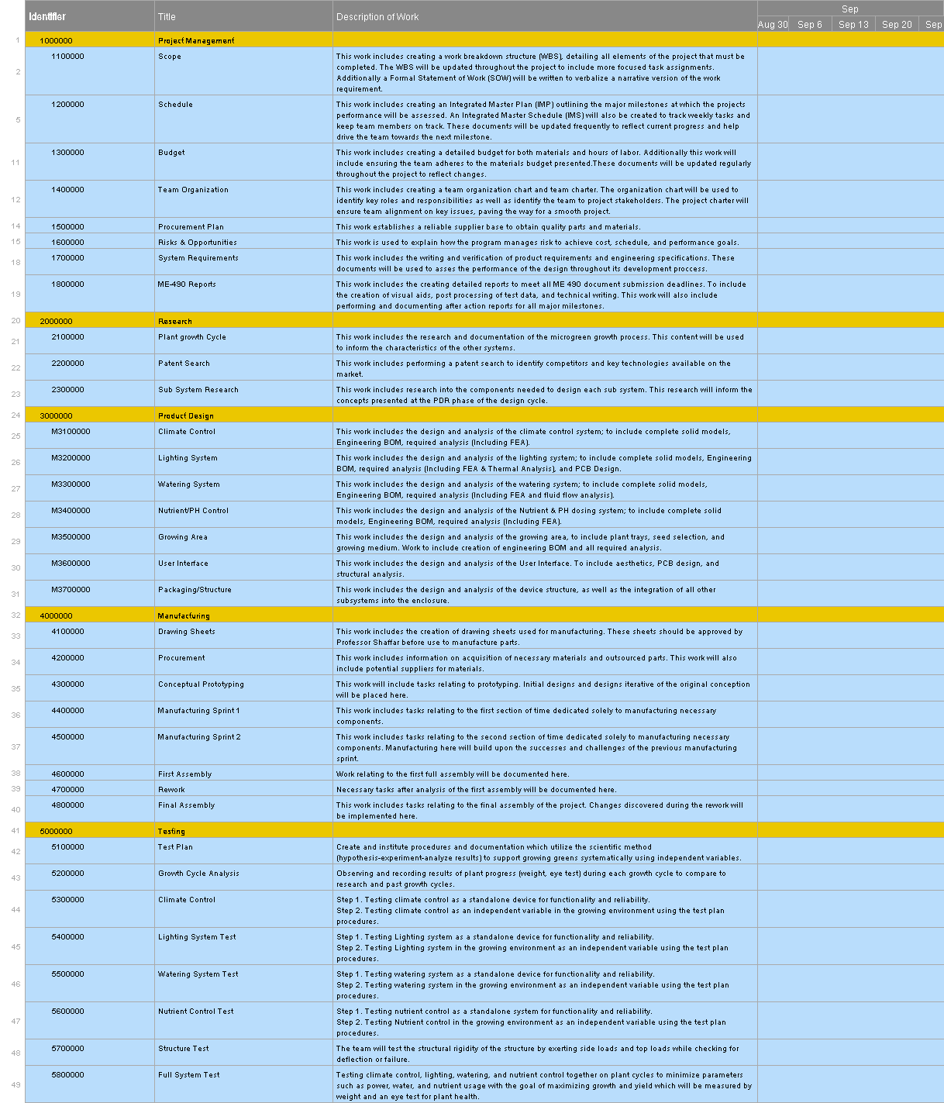

Figure# 2 WBS Table View

## Statement of Work (SOW)

Interest in microgreens has increased exponentially in the past several years, creating high demand for these tasty nutrition packed greens. However, consumers wishing to enjoy the health and flavor benefits of microgreens face two notable barriers: price and accessibility. This opens up the opportunity to design an automated microgreens environment that allows consumers to have cheaper access by creating a relatively inexpensive and easy to use machine.

For this project, the team requires knowledge of fluids, plant biology, controls, and heat transfer. With this knowledge, the team will create a design that responds to the plant growth testing performed. Subsequently the team can fabricate and test the product to validate its design. As a consumer product, the design should be made in accordance with FDA and FCC guidelines.

If the project is unable to meet these guidelines due to time or budget restrictions then documentation will be provided as to the necessary improvements to pass regulation. An additional guideline that the project will follow is designing for mid/large scale manufacturing techniques, such that production could be scaled in the future. These guidelines will ensure the project will be reliable, manufacturable, and legal to sell as a consumer good.

The project will consist of an enclosure that will house all of the electronics, sensors, pumps, motors, and growing trays. Each component will be modeled in Solidworks. Microgreens need to be given optimal lighting, watering, and climate. These parameters will be controlled and tuned by the team using test data.

The automated microgreens environment needs to be supplied with seeds, water, nutrients, and power. With all of these things, the device will grow microgreens and inform the customer when the product is ready for consumption. There should be minimal maintenance across the device’s lifecycle.

Timeline:

For the first semester of the project, we will be conducting research on the optimal microgreen growing conditions, designing the components for the final design, rapid prototyping, and working closely with the electrical team to integrate the mechanical and electrical components. The second semester will consist of purchasing materials and components, manufacturing and full system testing of the automated microgreens growing environment.

# 2.0 Schedule

## Integrated Master Plan (IMP)

Figure # 3 IMP Timeline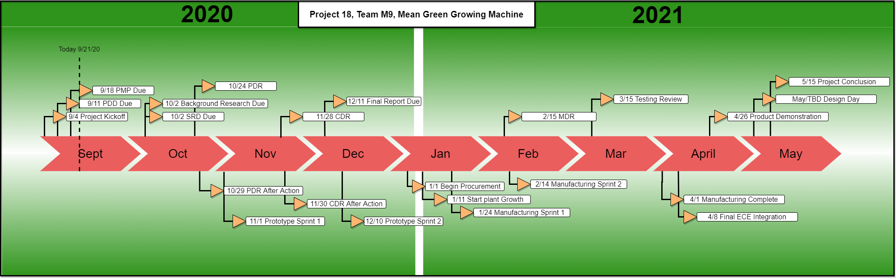

On the top axis of the IMP shown in Figure 3 ME-490 Milestones can be viewed, the bottom shows team milestones that have been created to drive project completion and promote team cohesion. Of note are the four “Sprints” outlined in the PMP, these one week events will be a structured team activity aimed at rapidly accelerating team progress, breaking out of iterative loops and arriving at the team’s next pain point faster.

## Integrated Master Schedule (IMS)

The Integrated Master Schedule provides a more granular, time based view of team events and tasks that must be completed. This document will be updated weekly to reflect individual assignments, progress on past tasks. Team M9 chose to use a software solution called “Smartsheet” to create an IMS and WBS, this software solution allows the team to assign members to a specific task, link documents and toggle between a Gantt and table view. These tools will help create accountability and drive team progress.

A live version of the team IMS can be viewed here: <https://bit.ly/2RAdBPF>

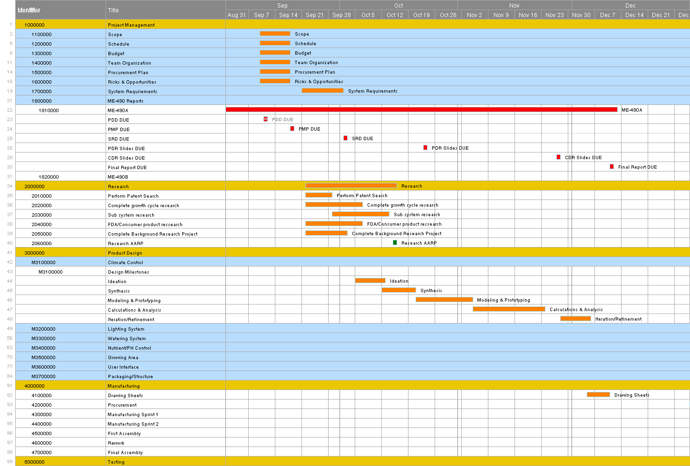 Figure # 4 IMS Gantt Chart ME490A

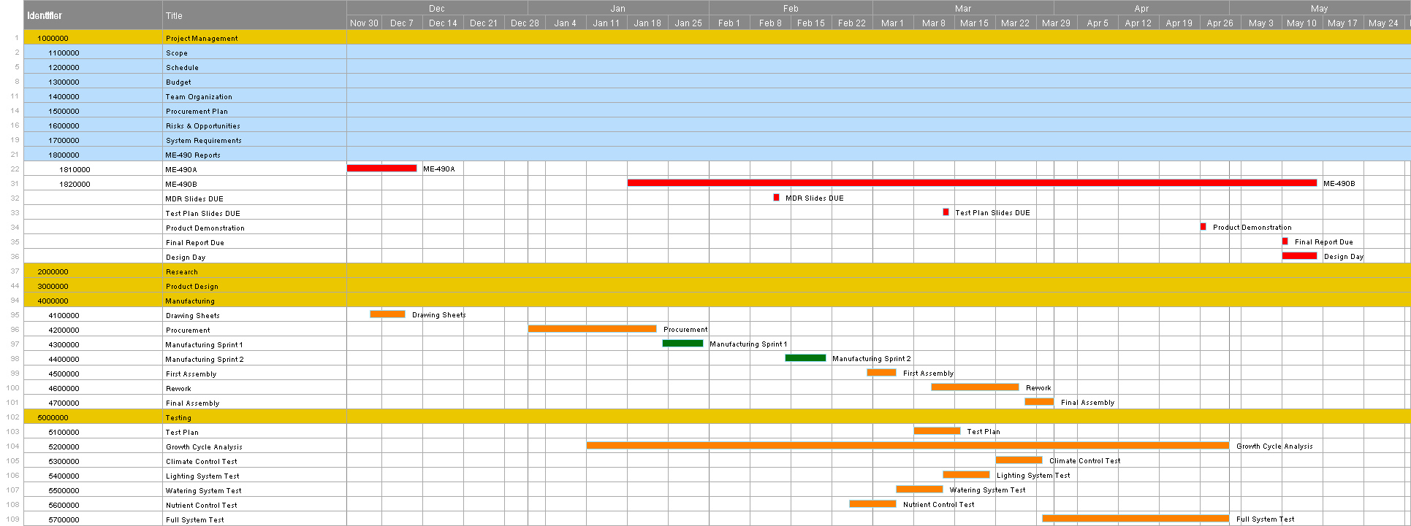 Figure # 5 IMS Gantt Chart 490B

# 3.0 Budget

Table # 1 Estimated Labor and Materials Budget

# 4.0 Team Organization

## Team Organization Chart

Figure # 6 Team Org Chart

## Team Charter

Roles and responsibilities of each team member:

|  |  |  |
| --- | --- | --- |
| Name | Title | Responsibility |
| John Berger | Project Lead/ Sponsor | * Team management * Manufacturing and design support * Testing support |
| Max Merritt | SEIT | * Integration of electrical and mechanical systems * Manufacturing and design support * Testing |
| Thuya Sathiamurthi | Design Lead | * Modeling systems using CAD * System integration * Testing |
| Conor Vasiliadis | Manufacturing Lead | * Manufacturing systems * Design support * Testing support |
| Dr. Scott Shafar | Professor | * ME Faculty advisor |
| Barry Dorr | Professor | * ECE Faculty advisor |

Table # 2 Team Charter

The purpose of this project is to work as a team to design and manufacture an automated microgreen growing environment for home use.Microgreens should be an affordable nutritious staple in every household, but due to high cost and limited accessibility this is not the case. Mean Green Growing Machines hopes to remedy this problem by allowing consumers to grow microgreens in their home at a fraction of the cost of store bought greens. Users will need to supply the device with power, water, seeds and nutrients. The machine will automatically grow the greens by varying temperature, light, water level and nutrient dosage. The greens will be harvested by the user once they are mature and should provide enough greens for at least one serving a day.

This will be accomplished using project planning and management information provided by Dr. Shafar and Dr. Williams.

If a team member is not upholding their role the team will meet and discuss the responsibilities of that individual. The discussion will include key points to mitigate disagreements and solve team issues.

1. Workload distribution
   1. If the member who is not upholding their role thinks that their workload is too high, there may be an opportunity to trade responsibilities to someone who can accomplish the work.
2. Civil disagreement
   1. If the member is withholding work because of a disagreement or differing opinion, the team will try to resolve the issue using a democratic process

We will evaluate our accomplishments by recognizing the people who achieve success in their role. The team will celebrate milestones but not lose focus of the end goal of the project.

People Resources:

|  |  |  |
| --- | --- | --- |
| Name: | Role: | Specialty: |
| Jessica McLaughlin | Zip Launchpad Team member | Branding/Business development |
| Anna Scavo | Zip Launchpad Team member | Micro Biology/Plant growth |

Table # 3 People Resources

# 

# 5.0 Procurement Plan

**Projected Materials Cost**

|  |  |
| --- | --- |
| **System:** | **Budget:** |
| Enclosure/Structural | $250.00 |
| Watering | $150.00 |
| Lighting | $275.00 |
| Climate Control | $50.00 |
| Plant Supplies | $150.00 |
| Nutrient/PH Control | $425.00 |
| Management Reserve | $195.00 |
| **Total:** | **$1,495.00** |

Table # 4 Projected Materials Cost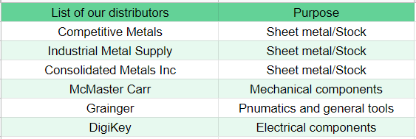

Table # 5: Distributor list

# 

# 6.0 Risks and Opportunities

Risk occurrence criteria is shown below in Table 6. A 5 level system was created to grade the varying likelihood of risks occurring over the course of the project.

|  |  |  |
| --- | --- | --- |
| Level | Likelihood | Probability of Occurrence |
| 1 | Very Low | 10% |
| 2 | Low | 30% |
| 3 | Moderate | 50% |
| 4 | High | 70% |
| 5 | Very High | 90% |

Table # 6 Risk Levels and Likelihoods

Risk consequence criteria is outlined below in Table 7. A 5 level system was created to establish criteria along 3 metrics, these being risks related to the performance of the project, the possible impact on the designed schedule, and impact on budget.

|  |  |  |  |
| --- | --- | --- | --- |
| Level | Technical Performance | Schedule | Cost |
| 1 | Minimal or no consequence to technical performance. | Minimal or no impact. | Minimal or no impact. |
| 2 | Minor reduction in technical performance or supportability, can be tolerated with little or no impact on program | Able to meet key dates with very minor slip in schedule.  Slip <1 week | Minor budget increase or unit production cost increases.  < ** (1% of Budget) |
| 3 | Moderate reduction in technical performance or supportability. Will have a minor impact on program objectives. | Minor schedule slip. Able to meet key milestones with no schedule float.  Slip < 2 weeks | Moderate budget increase or unit production cost increase  < ** (5% of Budget) |
| 4 | Significant degradation in technical performance or major shortfall in supportability.  May jeopardize program success. | Program critical path affected.  Slip < 1 month | High budget increase or unit production cost increase  < ** (10% ofBudget) |
| 5 | Severe degradation in technical performance; Cannot meet system requirements or listed specifications.  Will jeopardize program success | Cannot meet key program milestones.  Slip <2 months | Exceeds allowable  threshold  > ** (10% of Budget) |

Table #7 Risk Consequence Criteria

A list of risks was created in order to predict future problems that could arise. Foreseen risks could be mitigated by having a plan if risks were to occur. Risks are ordered from highest to lowest.

|  |  |  |  |  |
| --- | --- | --- | --- | --- |
| Number | Risk Statement | Level of Likelihood | Level of Consequence | Mitigation Method |
| 1 | If the SDSU machine shop remains closed due to the coronavirus, we will have to outsource parts. | 3 | 4 | Work closely with faculty to follow COVID-19 regulations and keep shop operational. |
| 2 | If we have to outsource parts, cost will dramatically increase, possibly causing the project to be over our initial budget. | 3 | 3 | Try to get a quote far in advance, possible discount for student teams. |
| 3 | If a part from outsourcing does not meet our design specs, it will have to be returned, delaying our current schedule. | 1 | 4 | Ensure drawings are clearly displayed to enhance clarity.  Order parts ahead of schedule to minimize potential impact. |
| 4 | If communication may suffer due to the virtual environment,this will lead to errors that compromise the design. | 1 | 4 | Regular online video meetings with clear work breakdown structure will ensure all team members are on the same page. |
| 5 | If a team member contracts coronavirus, the project may be put behind schedule due to loss in performance. | 2 | 2 | Team members will follow Federal and SDSU regulations/advice in staying healthy. |
| 6 | If a part breaks, we will have to reorder/remake it, putting us behind schedule and adding to the overall cost. | 2 | 2 | Will manufacture several copies of at-risk parts. |
| 7 | If lack of accountability in the virtual environment leads to loss of performance, this will put the project behind schedule. | 1 | 3 | Use of “Smartsheet” application will keep log of all tasks, including who is responsible and due date of listed tasks. |
| 8 | If an infectious team member spreads coronavirus to teammates, this will dramatically decrease performance which will cause the project to be behind schedule.  (Note: only if team decides to meet in person) | 1 | 3 | Team members will follow Federal and SDSU regulations/advice in staying healthy. |
| 9 | If water in our system leaks, possibly compromising electronics and requiring us to reorder parts. | 1 | 2 | Will test the water system outside of the unit, with no electronics installed. |

Table #8: Risk Reporting List

A risk consequence cube was created in order to better visualize the risks reported in the list above. Risks are plotted in a 5x5 cube according to their scoring in occurrence and consequence criteria.

|  |  |  |  |  |  |  |
| --- | --- | --- | --- | --- | --- | --- |
|  | 5 |  |  |  |  |  |
|  | 4 |  |  |  |  |  |
| 3 |  |  | 2 | 1 |  |
| 2 |  | 5,6 |  |  |  |
| 1 |  | 9 | 7,8 | 3,4 |  |
|  | 1 | 2 | 3 | 4 | 5 |
|  | Consequence  Figure #7 Risk Reporting Cube | | | | | |

*Note: No potential opportunities were created at the time of this document. Further risks and opportunities will be included as research progresses.*